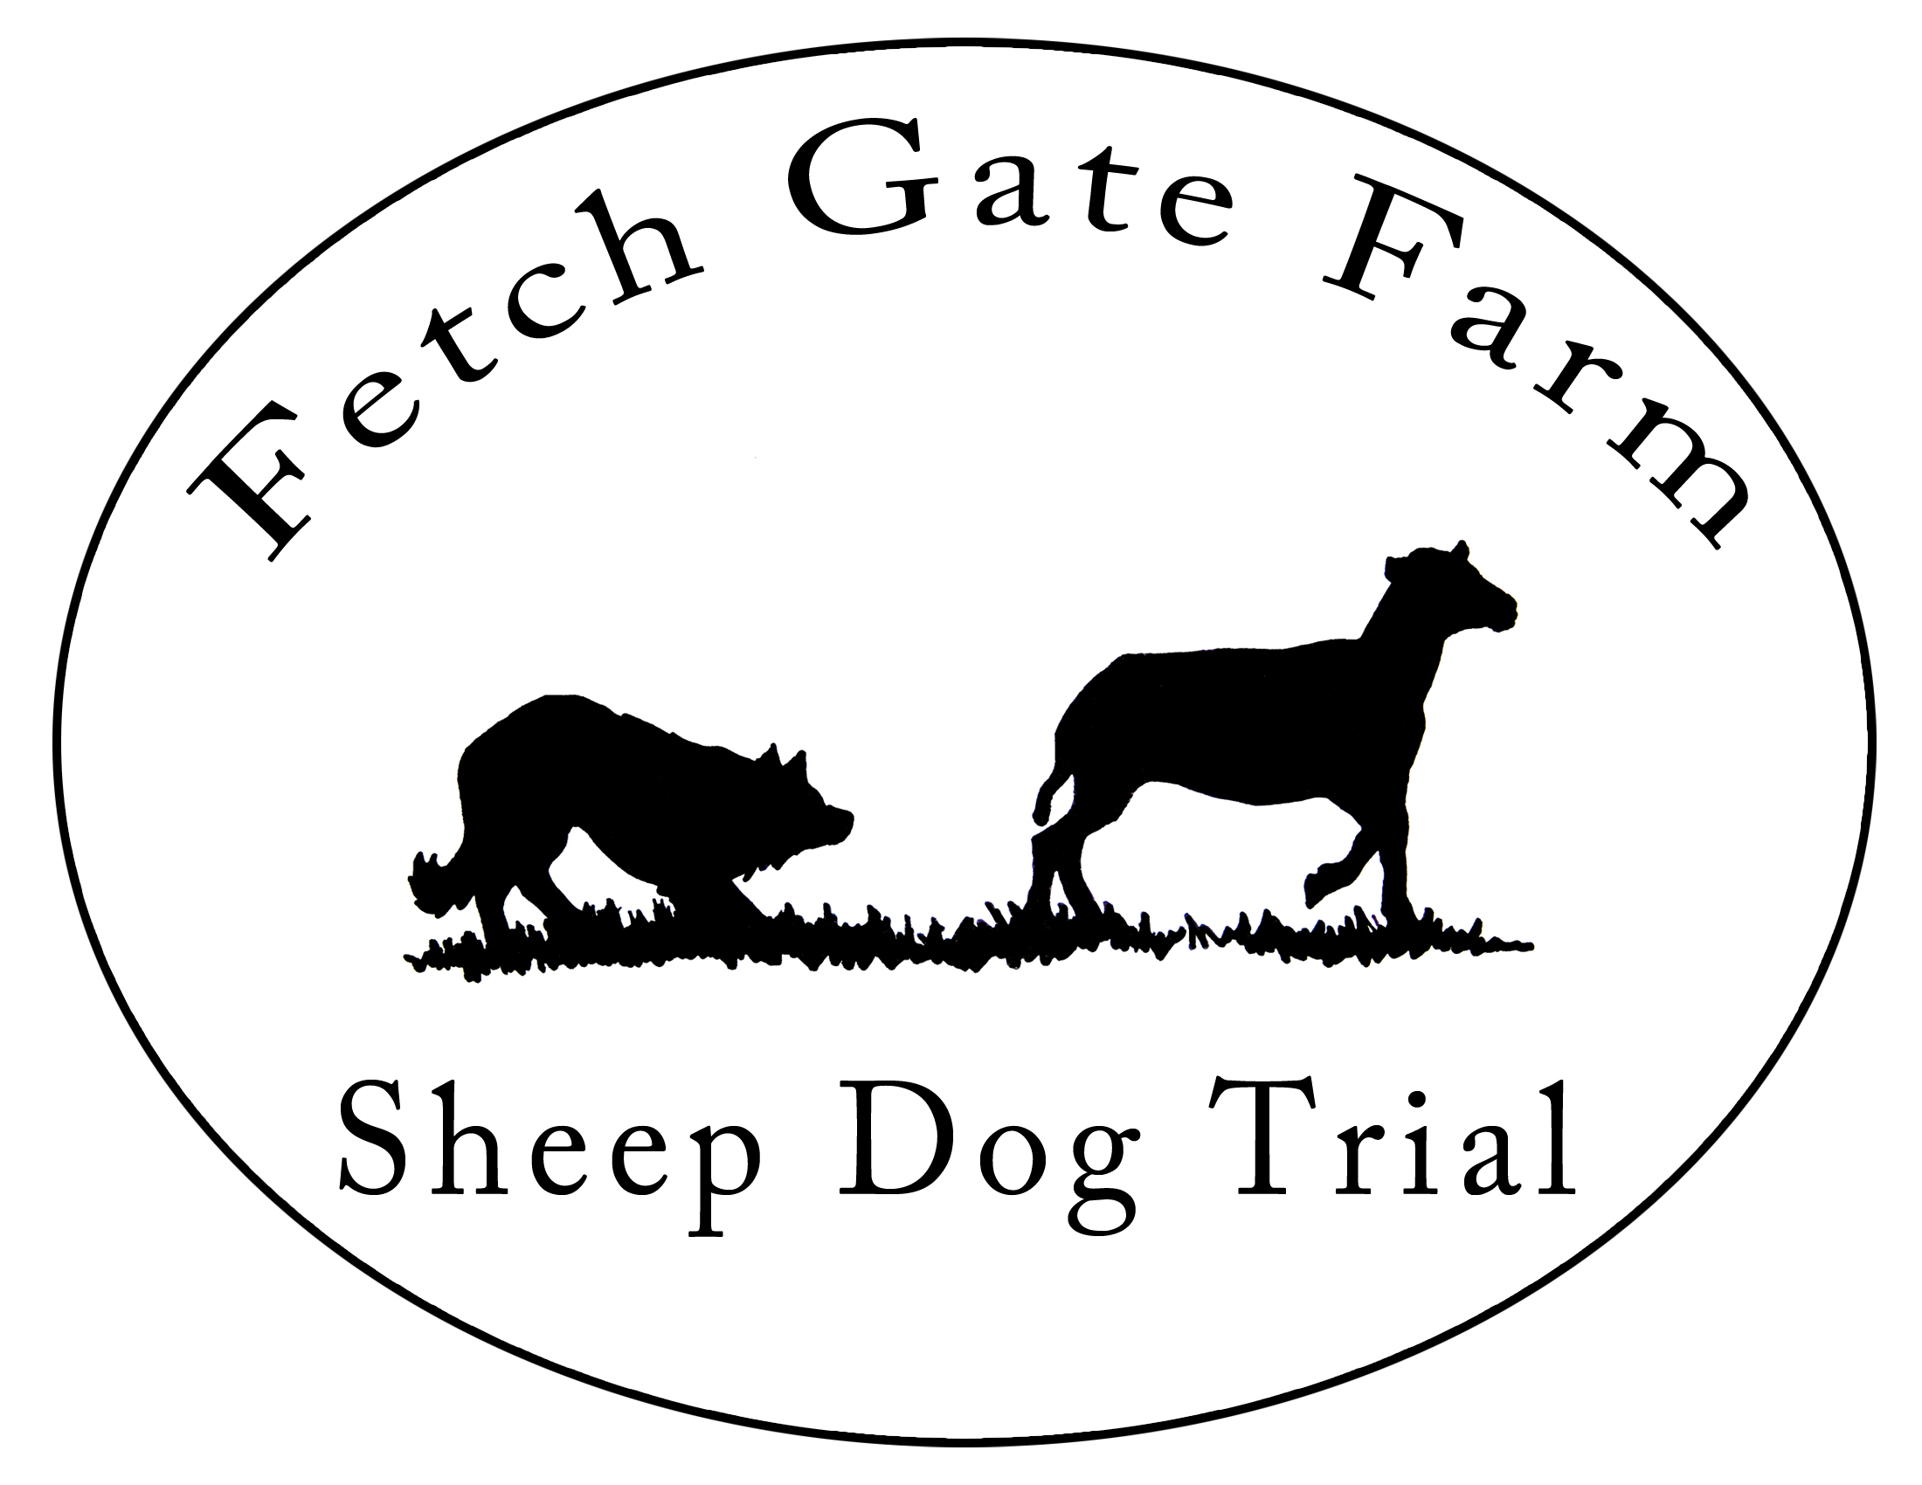

July 3 – July 6, 2025

2 USBCHA Nursery Trials
2 USBCHA/NEBCA Open Trials

Judges: Open – Werner Reitboeck
Nursery – Sharon Allswede

We are excited to host Fetch Gate Farm STD 2.0 again in 2025! Thank you to everyone who has attended and helped out the last few years and made the trial a great success. We will again be using Paul Batz’s flock of wool sheep. We are grateful to Roger and Heather Millen for their years of hosting the trial and for letting us continue the tradition. We all miss Roger and we hope that he’s happy that we have continued to bring dogs and handlers to Fetch Gate Farm. This year, we are bringing back the traditional pizza night and we hope everyone can attend (we will lift a glass to Roger!).

~ The Fetch Gate SDT 2.0 Committee (Kim Lippolis, Carolyn West, Paul Batz)

Entries Open 5/12/25 and close 5/29/25. Checks will be cashed on 5/30/25. Early entries will be accepted. We may accept third dogs in Open if there is space so please indicate on the entry form which dog is your third dog and send a separate check. Cancellations will be accepted until 5/29/25. All entries fees must be paid in USD; handlers outside of the US: please send a check and plan to bring cash (USD) to the trial or you can pay via PayPal or Venmo (contact Carolyn for details).

Trial Schedule: Thursday, July 3rd – Nursery 1 & 2
Friday, July 4th –Begin Open 1
Saturday, July 5th – Finish Open 1 and begin Open 2
Sunday, July 6th – Finish Open 2

Lodging: Camping space is available at the trial site. There are no hook-ups. Please plan to take all of your trash with you, this includes cans and bottles (everyone did a great job of this again last year – THANK YOU!).

Make checks payable to: Carolyn West

Mail entry and checks to: Carolyn West, 105 Lynbrook Rd, Paoli, PA 19301

Trial Address: Fetch Gate Farm, 1804 Babcock Hollow, Cortland, NY 13045

Questions: Email or text Carolyn West tobyfwest@gmail.com or 860-729-0550

Fetch Gate Farm SDT 2.0, July 3-6, 2025
Entry fees must accompany registration form
Nursery Open
$45/run $75/run
Dog | Nursery 1 | Nursery 2 | Open I | Open II | Fee
 |  |  |  | TOTAL

**Please indicate 3rd dog and send a separate check

Pizza dinner Fri, 7/4 (BYOB): YES NO (circle one)

Name ___________________________________________

Address ___________________________________________ Phone _____________________

City/State __________________________________________ E-Mail_____________________

I take full responsibility for the actions of my dog(s) and myself to any livestock, person or property associated with Fetch Gate Farm Sheep Dog Trials, Heather Millen and Fetch Gate Farm their management, Ox Creek LLC, Kimberly Lippolis, Carolyn West, and any employees/volunteers associated with the Trials. I will not hold the aforementioned parties responsible for injury to myself, my family, my vehicle, or my dogs(s). I will assume the financial responsibility for damages and veterinary care and/or the replacement value of stock ($375).

________________________________________________________ ____________________
(Signature) (Date)

We need volunteers! Please indicate if and where you are willing to help.

____ set out pen ___set out ___exhaust ___scribe ___scoring

