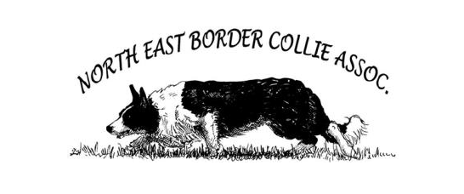

NEBCA Novice Finals
August 31, September 1, 2024
Cascade Farm, 370 Pettyboro Rd., Bath, NH
Judge: Dave & Mary Ellen Young

Information
There will be 3 runs over 2 days, best combined score from the two highest runs determines the placement. This may change if entries are overwhelming or weather or conditions dictate. Handlers may be limited to two dogs per class depending on the number of entries

Entries are currently open. Closing date & last day to withdraw with a refund is 21 August, 2024. Saturday start time will be determined based on the number of entries. Check the NEBCA Sheepdog Facebook Group or ListServ for updates.

Awards

- Champion & Reserve Champion per class
- Placement ribbons to 8th place per class
- Long Road recognition
- Alex McKinven award

- Betty Levin Award
Handlers’ Dinner
Catered barbeque dinner Saturday night. Dinners must be preordered for $25 each. Bring your own beverage.

To Qualify
The dog and handler must have earned at least two (2) points during the 2024 NEBCA novice year (from September 5, 2023 – August 21, 2024). The handler must have been a member of NEBCA when the points were earned. No retroactive membership is allowed. See the Novice Guidelines for additional information about qualifications for the Novice Finals.

Novice Finals T-shirt
Limited edition merch (t-shirts, sweatshirts) are available for purchase online in advance. Place your order early since items will ship directly to your home address. https://www.bonfire.com/nebca-novice-finals-1/

General Information
Please follow signs for handler parking, walk dogs in designated area, and clean up after your dogs. Remember to bring plenty of fresh water for yourselves and your dogs. No displaying puppies for sale. Anyone displaying poor sportsmanship will automatically be disqualified.
Entry questions? Contact Sharon Barrette (603) 918-0886
Accommodations
- Camping in field, no hookups
- Dog Friendly Hotels (please call to confirm they still allow dogs):
- Farm at Woods Hill (Chelsea) 289 Clough Rd. Bath 603-359-0214
- Nootka Lodge 4982 DC Hwy, Woodsville 603-747-2418
- All Seasons Motel 36 Smith St, Woodsville 603-747-2157
- Gale River Motel 1 Main St., Franconia, NH 603-823-5655
- Franconia, Sugar Hill, Littleton area (1/2-hour drive)
- Airbnb
NEBCA NOVICE FINALS ENTRY FORM

Classes: Novice / Pro Novice / Ranch
Dog’s Name | Long Road? | Class

Handler’s Name:
Address:
City: | State: | Zip:
Phone: | E-mail:

Make Checks Payable to NEBCA & mail to: Sharon Barrette, 168 South Rd., Kensington, NH 03833

Entry fee: # of dogs x $85 = ________________

Handlers Dinner: # of people x $25 = ______________

Total Enclosed: _______

Help make this a great Final for all! Please volunteer!
I will help with the following (please check):
Water |  | Scribe |  | Friday Set Up |  | Anything Needed
Exhaust |  | Scores |  | Sunday Take Down |  | Anything Needed

ALL HANDLERS MUST SIGN IN AGREEMENT TO THE FOLLOWING:
I assume all risks to self, dog(s), dependents and property while involved in any way with this trial. I agree to hold harmless NEBCA Inc., Cascade Farm, trial managers, trial committee, trial volunteers, judge and any and all others involved in this trial in any way. Furthermore, I agree to pay for any damage to persons, animals or property caused by me, my dog(s), or my dependents while involved in this trial. I understand that the trial managers will enforce safe and mannerly behavior and sportsmanlike conduct throughout the trial. Those in violation will be asked to leave without a refund. Additionally, I fully understand and take full responsibility that attending this event may put me and my family at risk for exposure to COVID 19 and will not hold any party associated with the event responsible in any way. I will also take as many precautions as required by trial managers to aid in the preventable spread of COVID-19.

Signature: __________________________________________________ Date: ____________________

